**ICM Web: The Interactive Chromatin Modeling Webserver**

Richard C. Stolz and Thomas C. Bishop [[1]](#footnote-1)1

Tulane University

Center for Computational Science

Lindy Boggs Center Suite 500

New Orleans, LA 70118, U.S.A.

Tel.: (504)862-3370, Fax: (504)862-8392

bishop@tulane.edu

**In this Document:**

**[Link to Nucleic Acids Research- ICM Web: The Interactive Chromatin Modeling Webserver](http://dna.ccs.tulane.edu/icm/Stolz-NAR2010.pdf)**

[**Overview**](#Overview)

[**Instructions**](#Instructions)

[**Sequence Selection**](#Sequence_Selection)

[**Energy Selection**](#Energy_Selection)

[**Sample Output**](#Sample_Output)

[**Algorithm**](#Algorithm)

[**Related Links**](#Related_Links)

**Overview**

General Usage: ICM-Web requires the user to input a sequence of DNA, select options for thermal fluctuation and placement then click "Go". ICM folds the sequence into a coarse-grain model of free DNA and a nucleosome array. The results page includes an energy level diagram, helical parameter plots, 3D molecular graphics displayed in Jmol, and options for saving data.

**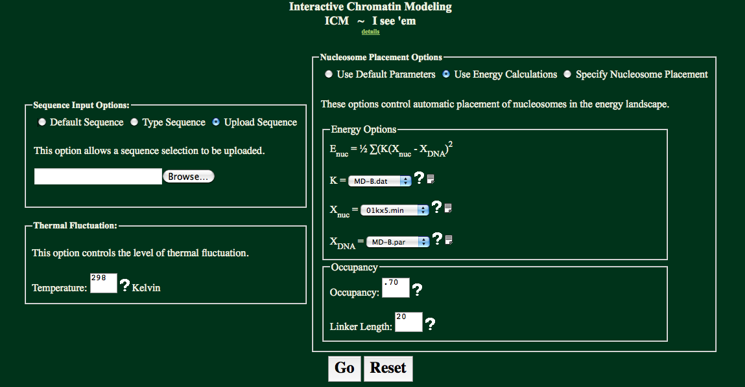**

The following pages describe:

[**Sequence Input Options**](#Sequence_Selection)

[**Energy Selection**](#Energy_Selection)

[**Back to Top**](#Index)

**Instructions**

**Sequence Input Options:**

There are three options in this panel. Select “Default”, which will use the default sequence, “Type Sequence”, which will allow a sequence to either be typed, or cut and pasted into a text box, or “Upload Sequence” which accepts FASTA formatted sequence files (without the header) for upload.

|  |  |  |
| --- | --- | --- |
| default.png |  | **Default Sequence:**  Using this option the MMTV sequence is used in calculations. Continue onto Energy Selection from here. |
| type.png |  | **Type Sequence:**  Having selected the “Type Sequence” radio button, a sequence may be entered into the text box as shown to the left. |
| upload.png |  | **Upload Sequence:**  Having selected the “Upload Sequence” radio button, a sequence may be uploaded using the form shown to the left. Uploaded files maybe in FASTA format. Headers from FASTA formatted files must be removed. Only ‘A’, ‘T’, ‘G’, &’C’ characters will be accepted (either uppercase or lowercase). All other characters will return an error. |

[**Back to Top**](#Index)

**Nucleosome Placement Options:**

There are three choices in placing nucelosomes in ICM. Select “Use Default Parameters”, which will use the default energy profile, “Use Energy Calculations”, which will allow an energy profile to be specified, or “Specify Nucleosome Placement” which accepts Nucleosome Start Sites as the placement parameter for the nucleosome.

|  |  |  |
| --- | --- | --- |
| default_E.png |  | **Use Default Parameters**  Using this option will use Xnuc=MD-B.par, Xnuc=01kxf.min, K = MD-B.dat, an occupancy of .7, and a linker of 20. This option was developed as to help those not familiar with the parameters used in calculations to get a general feel for the folding of DNA. |
| Energy.png |  | **Use Energy Calculations**  Using this option will allows for Xnuc, Xnuc, K, occupancy, and linker values to be specified. These are described in further detail below under the “[Energy Options](#Energy_Options)” heading. |
| nucleosome.png |  | **Specify Nucleosome Placement**  Using this option will allow nucleosome start sites to be specified. K, XDNA, and Xnuc values are all defined as in the “Use Energy Calculations” option. However, these values are used only in making the energy graph, not used in placing the nucleosomes. Only the specified start sites are used in placing the nucleosomes. |

[**Back to Top**](#Index)

**Energy Options:**

The “Energy Options” box is provided for the “Use Energy Calculations” option and the “Specify Nucleosome Start Sites” option. The “Use Energy Calculations” option uses these parameters in determining the nucleosome positioning, while the “Specify Nucleosome Start Sites” uses these parameters only in creating an energy plot.

**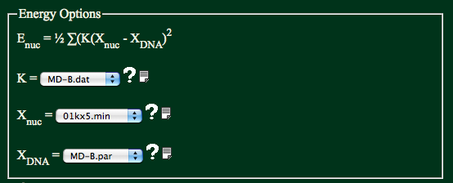**

K is the measure of the stiffness of DNA. It accounts for six degrees of freedom: Shift, Slide, Rise, Tilt, Roll, and Twist.

Xnuc is the shape of the nucleosome. This button lets you select from any of the available x-ray structures. All parameters extracted using 3DNA.

Xdna is the shape of the DNA when free in solution. This button lets you define the shape of free DNA to agree with x-ray or MD data.

**Thermal Fluctuation**

This determines the thermal fluctuations in the helical parameters for the regions of free DNA. The fluctuations yield a Gaussian distribution as determined by the chosen stiffness parameters and temperature.

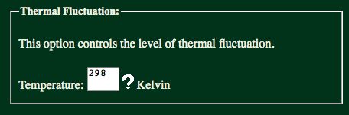

[**Back to Top**](#Index)

**Occupancy & Linker Length**

The occupancy determines how many nucleosomes are placed.

n > 1 : integer number of nucleosomes

n < 1 : percentage of maximum possible number of nucleosomes

n = 0 : constant spacing of "linker length" between nucleosomes

n < 0 : constant spacing with all locations shifted by n

The linker length is the minimum nucleosome- nucleosome distance in basepair.



[**Back to Top**](#Index)

**Sample Output**

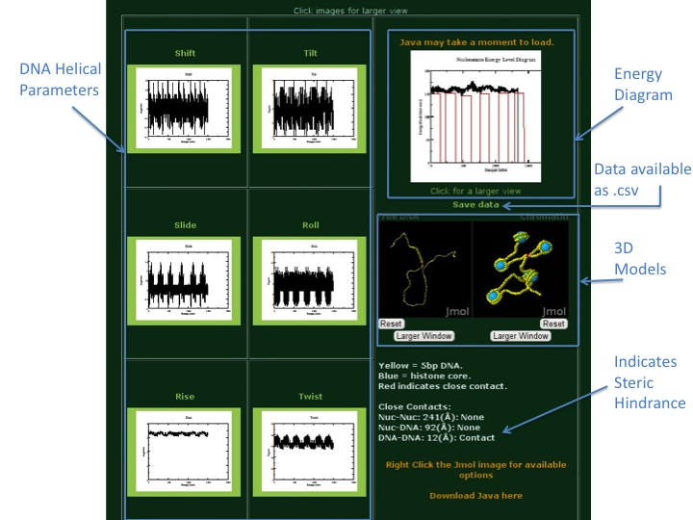Using the default sequence and default energy parameters ICM-Web will give the above output. Each output page includes the six DNA Helical Paramerter (Shift, Slide, Rise, Tilt, Roll, Twist) Plots, an Energy Diagram, downloadable data, two 3D models (one of free DNA and one of chromatin), and an indication of wether steric hinderance may be a problem in the model or not. For more details on the model’s output please reference the Nucleic Acids Research article referenced at the beginning of this

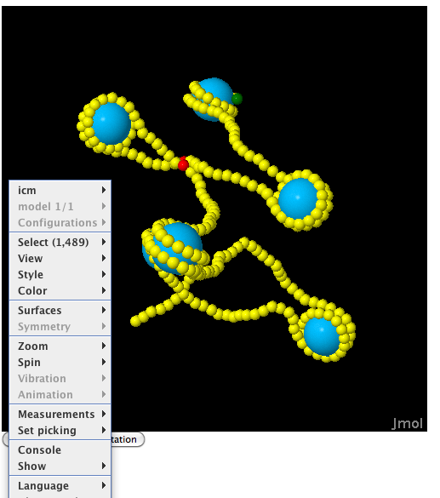 Doc

Users have full control of the Jmol interface upon right clicking on the object. Many options are available using the menu options, while more advanced users may utilize the Jmol Console as to manipulate the XYZ output as desired.

[**Back to Top**](#Index)

**Algorithm**

**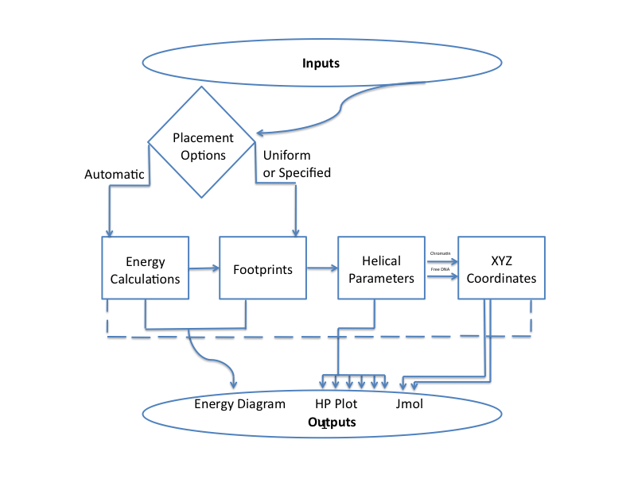**

Flow Chart:

Inputs ([Sequence Selection](#Sequence_Selection) and [Energy Selection](#Energy_Selection)) work through the alogrithm through one of the two placement options. Users may either specify to use automatic placement, in which the energy is calculated (option 1) or they may specify Nucleosome Start Sites or Uniform Spacing (option 2). If the energy is calculated an iterative process places nucleosome footprints at the lowest possible energy. Nucleosome Start Sites and Uniform Spacing use user determined Nucleosome Footprints. The Energy Calculations and Footprints are combined in each case as to provide the Energy Diagram. The Footprints are then combined with the Helical Parameters Selected to provide the Helical Parameter Plots. A XYZ coordinate file is then created for the Free DNA and Chromatin models.

[**Back to Top**](#Index)

**Related Links**

Fine Structure: <http://www.cs.bgu.ac.il/~nucleom/>

NuPop: <http://nucleosome.stats.northwestern.edu/>

Segal Lab: <http://genie.weizmann.ac.il/software/nucleo_prediction.html>

nuScore: <http://compbio.med.harvard.edu/nuScore>

[Nucleosome Explorer: http://edsc.rockefeller.edu/nucleosome/](http://edsc.rockefeller.edu/nucleosome/)

[**Back to Top**](#Index)

1. [↑](#footnote-ref-1)